**I535-O Project B: Analyzing Large Text Corpora**

*This project description is available electronically at* [**https://github.com/dimitargnikolov/book-project**](https://github.com/dimitargnikolov/book-project) *. You can access the document here or you can follow the link.*

**Due: Monday, December 5 @ 11:59pm**

**Introduction**

In this project you will create a database of books and learn how to analyze and visualize their text. In particular, you will learn how to techniques from natural language processing (NLP) to automatically discover the characters in a book, quantify the strength of relationship between them, find the important characters, identify groupings between them, and finally, create a beautiful visualization of your analyses. We will walk you through a case study of how to:

1. Download a book from [Project Gutenberg](https://www.gutenberg.org/) and import it into MongoDB.
2. Use [Python](https://www.python.org/) and its [Natural Language ToolKit (NLTK)](http://www.nltk.org/) library to extract a list of characters the book.
3. Learn how to process the text of the book to create a network of relationships between the characters.
4. Learn a couple common ways to analyze a network using network science tools.
5. Visualize the character relationships using the [Gephi](https://gephi.org/) graph visualization platform.

You will follow the case study, then if you choose, you will identify other content to analyze and share your insights.

**Project grading is as follows**: a student who follows instructions, does the entity recognition analysis for Les Miserables, and writes a reasonable report about his or her interpretations of the results, and submits all required documents will receive up to 93 points. A student who selects new content to analyze and chooses the content in a way that reasoned interpretation is possible (the content is coherent with respect to characters), and further that the student demonstrates through their report that they carried out a reasoned intrepetation of the analysis results will receive a grade of up to 100%.

**Extra Credit: Option 1 Going a Step Beyond in Refinement and Quality Analysis:** A student engages in an exceptional analysis using both originally chosen content, parameter tuning, data cleaning, and analysis interpretation (such as meaningfully interpreting results through steps of cleaning) will receive up to 10 extra credit points.

**Extra Credit: Option 2 Analysis using HathiTrust Data Capsules:** Available to the first 20 students who sign up, students will carry out the Les Miserables analysis using the HathiTrust Research Center Data Capsules. There are hundreds of files for Les Miserables (it has multiple parts and duplicate versions making a whopping 536 relevant books) in the HathiTrust digital library. Your report will compare the results of analysis on HathiTrust Les Miserables content compared to the book in Project Gutenberg. A student will receive up to 10 extra credit points for his/her own work. Sign up with Professor Plale. Availability is on a first come, first serve basis. This project will not rely on existing tutorial material so is best suited for self-starters with time, tolerance, and background for pushing the bleeding edge and contributing to research.

**Prerequisites**

You need to be familiar with what we have been covering during the last several weeks of discussions. In particular, you need to:

1. Have your Jetstream account and allocation ready to use. If you don't, please refer to the [XSEDE Account Guide](https://iudatascience.soic.scholargrid.org/asset-v1:iudatascience+I535-I435-B669+FALL_2016+type@asset+block/Creating_XSEDE_Account__Jetstream_Tutorial_.pdf" \t "_blank) and the [Using Jetstream](https://iudatascience.soic.scholargrid.org/asset-v1:iudatascience+I535-I435-B669+FALL_2016+type@asset+block/Using_Jetstream.pdf" \t "_blank) tutorials.
2. Be able to upload files to your Jetstream instance. If you don't know how to do this, please refer to the [Setting Up SSH Keys](https://iudatascience.soic.scholargrid.org/asset-v1:iudatascience+I535-I435-B669+FALL_2016+type@asset+block/Generating_SSH_Key.pdf" \t "_blank) and [Transfering files to Jetstream](https://iudatascience.soic.scholargrid.org/asset-v1:iudatascience+I535-I435-B669+FALL_2016+type@asset+block/Transfering_Files_to_Jetstream.pdf" \t "_blank) tutorials.
3. Have the [Linux command cheat sheet](https://iudatascience.soic.scholargrid.org/asset-v1:iudatascience+I535-I435-B669+FALL_2016+type@asset+block/LinuxCommandsCheatSheet.pdf" \t "_blank) we posted earlier in the class handy.

**Setup**

**Use of Jetstream**

We will continue to use Jetstream in this project. With a new allocation and the issues from a couple weeks ago largely resolved, this time you should have a smooth experience if you follow these instructions.

There is a new image for this project that comes pre-loaded with necessary software such as Python and mongodb. Head on over to [use.jetstream-cloud.org](https://use.jetstream-cloud.org/" \t "_blank) and create a new instance of the *I435/I535/B669 Project B* image (created either by user *atmoadmin* or *dnikolov*). You can find the image by searching for *I435*:

[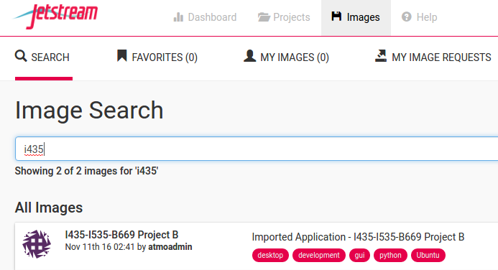](https://github.com/dimitargnikolov/book-project/blob/master/images/jetstream-image.png)

When you create the new instance, please use the **Jetstream - TACC** provider and the **tiny** instance size to avoid any hanging issues or needlessly spending our allocation:

[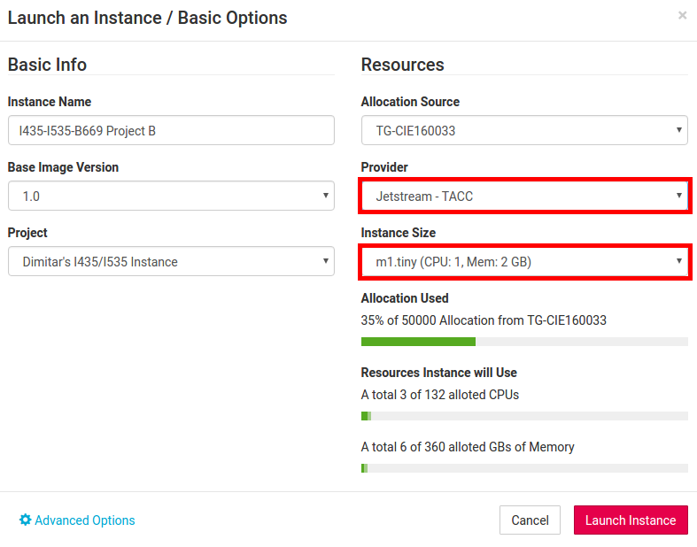](https://github.com/dimitargnikolov/book-project/blob/master/images/create-instance.png)

**Set Up Directories and Download Code**

Once your instance is active, go ahead and access it via the *Web Shell* or an *ssh* client of your choice.

You need to set up a directory for the project and download the code for it using *Git*, a popular system for version control and project file management.

$ mkdir ~/Projects $ cd ~/Projects $ git clone https://github.com/dimitargnikolov/book-project.git $ cd book-project

In addition, you need to copy the sample start-up script provided with the project code to your home directory as follows:

$ cp sample.bashrc ~/.bashrc $ source .bashrc

These commands create a start-up script called .bashrc in your home directory. .bashrc is a special file that Linux looks for when it starts up, and thus, it will be executed every time your instance starts. In this case, since you already have your instance started, we executed the file manually with the source command. You can take a look at the contents if you like:

$ cat ~/.bashrc

All it does is it creates two environmental variables -- one that allows the code to easily find your project directory, and the other, that makes sure your instance knows where to find the correct version of Python.

With this, the setup of your environment is done. You don't need to execute any of the previous steps again. Unless otherwise noted, all commands in this document should be executed on your Jetstream instance, inside the ~/Projects/book-projectdirectory.

**Case Study: The Characters Network for *Les Miserables***

In this case study, we will walk you through all the steps needed to extract and visualize the character relationships in the book *Les Miserables*. The case study gives you the tools to analyze any collection of texts and extract and visualize a network of the people mentioned. The steps are:

1. Insert your text(s) in MongoDB.
2. Write a find query to retrieve all the texts from MongoDB.
3. Pass the results of the query to the tag\_texts and find\_people functions to find any people mentioned in the text.
4. Clean up the list of people using the remove command.
5. Use the create\_network function to create a network representation of the relationships between people in the texts.
6. Use Gephi to find important characters and groups of similar characters in the network.

**Adding a Book to MongoDB**

We'll start with a single book, *Les Miserables*, that you can download from [Project Gutenberg](https://www.gutenberg.org/). From the main page, you can go to *Book Search Page*, then *Popular*, and click on the book title towards the top of the list (third position as of Oct 3, 2016). From the download page, choose the **Plain Text UTF-8** format and download it to your ~/Projects/book-projectA/data directory as les-mis.txt. You can do all this from the command line as follows:

$ wget https://www.gutenberg.org/files/135/135-0.txt -O ~/Projects/book-project/data/les-mis.txt

Next, you need to insert the contents of the book in the books collection in MongoDB. As mentioned in the introduction, to do this, you will use Python and its PyMongo extension instead of the MongoDB shell, because Python provides the environment and libraries to complete not only this, but other necessary tasks such as reading files, running syntactic analysis and gathering statistics about the text.

$ cd ~/Projects/book-project $ python

>>> import pymongo >>> from pymongo import MongoClient >>> mongodb = MongoClient() >>> db = mongodb.projectA >>> with open('data/les-mis.txt', 'r') as f: text = f.read() >>> db.books.insert({'author': 'Victor Hugo', 'title': 'Les Miserables', 'text': text})

You will notice that as soon as you type python the shell symbol changes from the familiar $ to >>>. This means you are in the Python shell (as opposed to the system shell). You can exit the Python shell at any time by pressing Ctrl-D.

The first four lines from the Python shell above set up access to MongoDB and the projectA database through the db variable. From there on, you can use db to execute MongoDB statements in an almost identical way to what you're used to from the MongoDB shell shown to you during discussion.

The fifth line, reads the contents of the book that you downloaded and stores it in the variable text. In Python, you can see the contents of a variable at any time by typing its name, so if you type

>>> text

you will see the contents of the book scroll through your screen. This is too much text to be useful, so you can type the following instead, to only look at the first 100 characters of the text:

>>> text[:100]

You should get in the habit of looking at the contents of variables in this way, as it will prove useful when debugging any errors.

Finally, the last line should be familiar, since it's identical to an insert command you would issue in the MongoDB shell. It puts the book in the books collection in MongoDB as an object consisting of an *author*, *title* and the *text* of the book.

You now have the text of the book and in MongoDB for later use and analysis.

**Extracting the Characters from a Book**

Coming up with a list of all characters in a book would be a daunting task even for a book you are familiar with. Fortunately, we can automate this process using a technique called [named-entity recognition](https://github.com/dimitargnikolov/book-project/blob/master). This technique uses knowledge about a language's grammar combined with statistical properties of text to assign entities in the text to pre-defined groups such as persons, organizations, locations and so on. The current state-of-the-art in named-entity recognition is not perfect, but it's pretty good and you will use it to extract a list of characters in *Les Miserables*.

Named-entity recognition is a common task in natural language processing applications and algorithms for it have been implemented in many languages. We will use Python's nltk library to extract a list of person-entities from the book. However, even using these libraries can be a little tricky and beyong the scope of this project, so we have written some code that makes working with book text simple. The code is located in the lib.py file that came with th e project. You do not need to understand how the code in this file works, only how to use it. For example, loading the book and extracting the characters is simple.

First, you need to make sure you have access to MongoDB so you can load the contents of the book:

>>> import pymongo >>> from pymongo import MongoClient >>> mongodb = MongoClient() >>> db = mongodb.projectA >>> mongo\_results = db.books.find({'title': 'Les Miserables'})

In the last line, you are using a find MongoDB command to retrieve all books in the database with the title *Les Miserables*. Of course, only one book will match the search query, but keep this in mind in the second half of the project where you will be using your own data.

You can load the text from the search results and run the character extraction algorithm in three lines. The code might take a few seconds to run, so be patient:

>>> from lib import \* >>> tagged\_texts = tag\_texts(mongo\_results) >>> chars = find\_people(tagged\_texts)

If you now view the contents of the chars variable, you will see something like this:

The results are not perfect -- there are some characters that shouldn't be there like Which, Project Gutenberg, Project Gutenberg-tm and so on. This is in part due to the fact that the text we are working with is not entirely clean and contains a header and footer that is not actually part of the book. In part, this is due to the entity-extraction algorithm not being perfect and getting fooled by non-traditional capitalization in the book.

This is another illustration of the need for setting up a data pipeline to clean your data before it is analyzed. In this case, we will clean the data manually, since setting up a data pipeline is beyond the scope of this project.

You can quickly clean up the list of characters as follows:

>>> chars.remove('A') ...

Continue using the remove function as above for other strings that were extracted as characters but should not have been. You don't need to have a perfect list of characters to continue to the next step, but do your best.

**Inferring Character Relationships**

Now that you have a list of characters you are interested in analyzing, we want to infer how closely related they are to each other. What we mean by that is that characters who appear in the same scenes or talk to each other often, should be considered more closely related than characters who don't. We can represent the character relationships as a network where each node is a character, and each edge denotes the strength of relatedness between two nodes. Using a network representation like this is very powerful since it will later allow us to leverage a lot of knowledge about [network analysis](https://github.com/dimitargnikolov/book-project/blob/master" \t "_blank) and apply it directly to our problem in this project.

How do we determine how strong the edges between characters should be? We will derive this from the text of the book itself assuming that characters that appear close to each other on a page are also more closely related. Programatically, this involves scanning the text of the book using a sliding window of N characters and marking increasing the strength of relatedness between any characters who happen to be in the window at the same time. For example, consider this paragraph:

"**Fantine, Dahlia** *and* **Zéphine** *have been teasing us for nearly a year to give them* a surprise. We have promised them solemnly that we would. They are forever talking about it to us, to me in particular, just as the old women in Naples cry to Saint Januarius, 'Faccia gialluta, fa o miracolo, Yellow face, perform thy miracle,' so our beauties say to me incessantly, 'Tholomyès, when will you bring forth your surprise?' At the same time our parents keep writing to us. Pressure on both sides. The moment has arrived, it seems to me; let us discuss the question."

Here, we are using a window of 15 characters (the italicized portion of text). We start at the beginning of the paragraph and we already see that *Fantine*, *Dahlia* and *Zephine* appear close together, so we will update the network representation to strengthen the edge between the *Fantine* and *Dahlia*, *Fantine* and *Zephine*, and *Dahlia* and *Zephine* nodes.

We've done all of this for you in lib.py, so you can simply use the following function to create the network representation:

network = create\_network(book, chars, N=15)

Note that the number of characters in the sliding window can be specified. In this case, it's N=15.

We are going to save the network as a file, so we can use network analysis and visualization tools on it:

import networkx as nx nx.write\_gml(network, os.path.join('networks', 'les-mis.gml'))

The details of the command above are not important. Suffice it to say, an les-mis.gml file will appear in the networks folder of your project.

If you look at the file that was generated, you will see something that looks like this:

graph [ node [ id 0 label "Valjean" ] node [ id 1 label "Fantine" ] ... edge [ source 0 target 19 weight 1 ] edge [ source 1 target 16 weight 1 ] ... ]

**Analyzing and Visualizing the Network of Characters**

To analyze this network, you will use the [Gephi graph analysis and visualization platform](https://gephi.org/" \t "_blank). We will do a tutorial on Gephi during discussion, and will provide a recording of it as well. At the end of the tutorial, you will produce a visualization of the characters in *Les Miserables*. Your visualization should end up looking similar to this:

[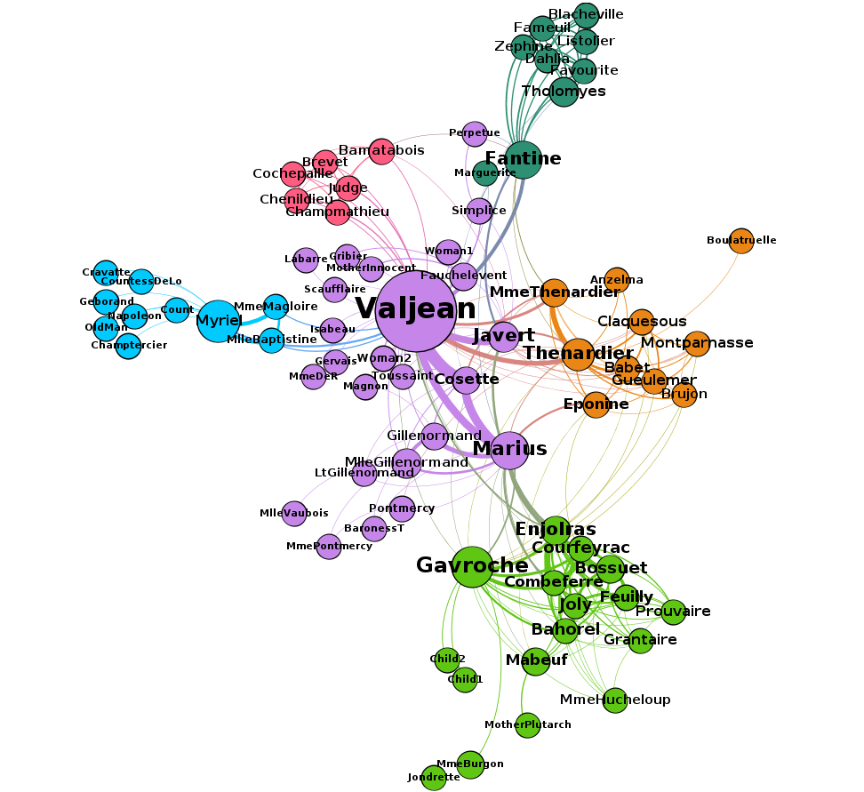](https://github.com/dimitargnikolov/book-project/blob/master/images/les-mis.png)

**Analyzing Other Texts (Minimal Plus portion of project)**

The case study gives you the tools to analyze any collection of texts and extract and visualize a network of the people mentioned. The steps are the same:

1. Insert your text(s) in MongoDB.
2. Write a find query to retrieve all the texts from MongoDB.
3. Pass the results of the query to the tag\_texts and find\_people functions to find any people mentioned in the text.
4. Clean up the list of people using the remove command.
5. Use the create\_network function to create a network representation of the relationships between people in the texts.
6. Use Gephi to find important characters and groups of similar characters in the network.

For this part of the project, repeat this analysis for a book or a collection of texts of your choosing. You can take another book from Project Gutenberg, a set of books who share characters, or a set of news articles or blog entries. The source and format of the text is up to you, as long as you can import it into MongoDB.

To make your life easier, we'll provide you with a function that can import a collection of text files into MongoDB. Say, you've collected your texts as plain-text files and you've uploaded them to your Jetstream instance in ~/Projects/i435-projectA/data. Then, you can important all these files in the Python shell as follows:

>>> from lib import \* >>> insert\_txt\_to\_mongodb('data/')

The script will insert any .txt file in the data directory in MongoDB with attribute title set as the name of the file, and attribute text set to the text inside the file.

Using this script, you are not limited to a single book or document.

**Analyzing Les Miserables content using HathiTrust Data Capsule (Extra credit option 2)**

Where Project Gutenberg has a single cleaned up version of Les Miserables, the HathiTrust Digital Library has numerous versions available across multiple parts. Up to 20 students will carry out the analysis of Les Miserables not in their XSEDE Jetstream virtual machine, but in a special virtual machine in the HathiTrust Research Center (HTRC) that has security controls enabled for analysis over in-copyright content. A VM instance in HTRC is called a Data Capsule. The student will use the NLTK toolkit and python already installed in the Data Capsule, and work with the HathiTrust Research Center development team to install other tools needed to carry out make a complete pipeline for analysis. See here for more details about the Data Capsule: <https://wiki.htrc.illinois.edu/display/COM/HathiTrust+Research+Center+Documentation>.

All students are encouraged to sign up for an account on the HathiTrust web site <https://analytics.hathitrust.org/>. Once there, select "capsule" from the menu bar at the top, and go through the steps of creating a Data Capsule. You will need to create another password for the capsule - a "feature" the team is trying to remove. **Any student can play with a Data Capsule during the period 14-20 November 2016. After 20 November student data capsules will be removed and only the 20 students who signed up to work on the project will have their Data Capsule available to continue.**

Sign up with Professor Plale. Availability is on a first come, first serve basis. This project will rely not rely on existing tutorial material so is best suited for self-starters with the time, tolerance, and background for pushing the bleeding edge and contributing to research.

**Report and Deliverable**

For this project you will submit a portfolio that contains a final report and files that demonstrate your work. You will submit the portfolio of materials through Canvas.

**Report**: You will submit a report (DOC, DOCX, PDF) that must contain:

1. Lists all sources of help that you consulted, including other students. You need not mention AIs nor class resources.
2. Answers the questions in Minimal, Minimal Plus, and Extra Credit Options 1 or 2 depending on which parts of the project you decide to do.

**Minimal**: Everyone does the Les Miserables analysis, so your report must include below:

1. Is a window of size 15 a good window size for the characters that you think are related?
2. What are the strengths and weaknesses of a larger window size? Give an example of a relationship that was missed because of a window size of N=15
3. Include a copy of the network graph (or portion of it) that you generated for the characters in Les Miserables from Gephi (PDF)

**Minimal Plus**: For those who carried out the Les Miserables analysis plus analysis over own content, your report will include all for "Minimal" plus three steps below:

1. When you analyzed texts of your own choosing that you're familiar with or interested in, did you glean any insights from this type of analysis that would be harder to glean from a simple readthrough?
2. Include a copy of the graph (or portion of it) that you generated for the characters in content you chose (PDF)
3. An archive containing the text(s) you chose to analyze (ZIP).

**Extra Credit Option 1**: Going a Step Beyond in Refinement and Quality Analysis: Your report will include Minimal and Minimal Plus as well as below:

1. When you extract the characters, create the network representation and apply the network analysis algorithms, there is some fine-tuning of the algorithms that needs to happen. Try exhaustively cleaning your list of characters, adjusting the parameter values for the length of the text window, or the number of communities. How do the results differ? Did you need to do a lot of fine-tuning to produce a visualization that was useful and easy to understand? What ways of automating this fine-tuning can you think of?
2. Include a copy of the graph (or portion of it) that you generated for the characters in content you chose that went through the cleaning that you carried out (PDF)
3. An archive containing the text(s) you chose to analyze in the second part of the project (ZIP)

**Extra Credit Option 2**: Analysis using HathiTrust Data Capsules: Your report will include Minimal and Minimal Plus as well as below:

1. Your report should include a discussion of issues that you encountered (you will be helping develop a stronger Data Capsule)
2. Carry out a comparison of the network graph that you produced for the Gutenberg book against the network graph generated on the content in HathiTrust digital library. Offer explanations for the differences that you see.
3. Include a copy of the graph (or portion of it) that you generated for the characters (PDF)

POST YOUR COMPLETED PROJECT REPORT & DELIVERABLES IN CANVAS: